**Rules for “Craftix” (Creativity Competition):**

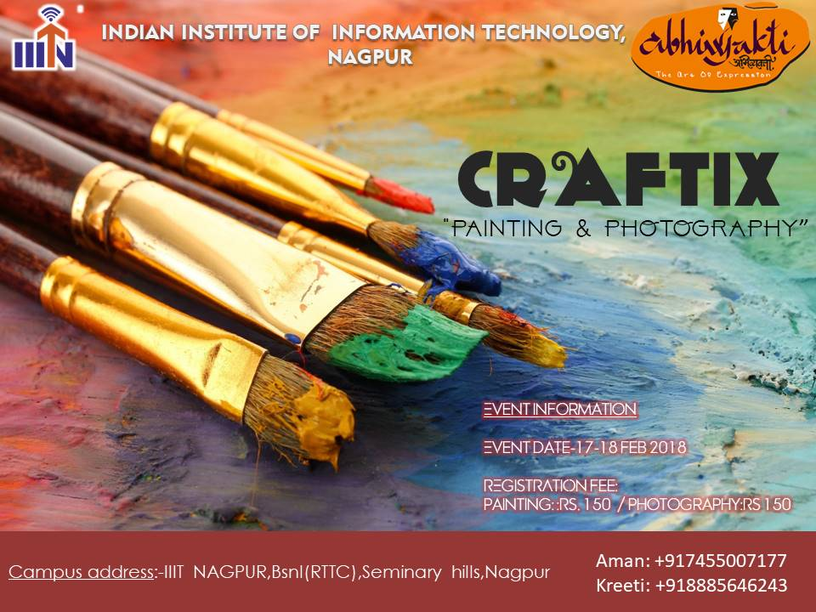

**Rules for Photography Competition:**

* Participants have to register online by filling up the google forms provided in the official website  [www.abhivyakti.g](http://www.abhivyakti.ga/)a.
* Participants must possess a valid college identity card of their institution.
* The Competition is open to all students.
* Craftix will be the exhibition of the pictures submitted by the participants which will begin on 17th Feb 2018 and the final results will be disclosed at closing ceremony on 18th Feb 2018.
* Participants need to print their picture on an A4 size photo paper for displaying in the exhibition.
* Participants need to mail their pictures at [amansoni.hts@gmail.com](mailto:amansoni.hts@gmail.com) till 16th Feb 2018.
* The picture must have the proper caption written in English only with the name of author.
* The photographer(s) must be the author(s) of the picture submitted in his/her name.
* The picture can only be entered once. Pictures submitted more than once will lead to cancellation of participation.
* Jury’s decision will be the final word and no arguments will be entertained.
* If any unfair practices are found during the event then it will lead to disqualification of the individual.
* Every participant(s) are required to fill up the “undertaking”.
* **Please, do collect your identity cards available at the registration desk.**

**Note:** In case of any discrepancy, decision made by the Team

Abhiyakti’18 will be final. Amount of prize can be changed.

**REGISTRATION FEE**: **₹** 150.

**PRIZES:**

**1st Winner: ₹ 2000**

**Contacts:**

**Aman Soni: +91 7455007177**

**Keerti Bajaj: +91 7013542899**

|  |  |
| --- | --- |
|  |  |

**Rules for Painting Competition:**

* Participants have to register online by filling up the google forms provided in the official website  [www.abhivyakti.g](http://www.abhivyakti.ga/)a.
* Participants must possess a valid college identity card of their institution.
* The Competition is open to all students.
* Craftix will be the exhibition of the paintings submitted by the participants which will begin on 17th Feb 2018 and the final results will be disclosed at closing ceremony on 18th Feb 2018.
* Participants need to draw their painting on an A2 size sheet for displaying in the exhibition.
* Participants need to mail the pictures of their painting with complete details (Name/College name/ caption) at [amansoni.hts@gmail.com](mailto:amansoni.hts@gmail.com) till 15th Feb 2018.
* The painting must have the proper caption written in English only with the name of author.
* The participant(s) must be the author(s) of the picture submitted in his/her name.
* The painting can only be entered once. Pictures submitted more than once will lead to cancellation of participation.
* Jury’s decision will be the final word and no arguments will be entertained.
* If any unfair practices are found during the event then it will lead to disqualification of the individual.
* Every participant(s) are required to fill up the “undertaking”.
* **Please, do collect your identity cards available at the registration desk.**

**Note:** In case of any discrepancy, decision made by the Team

Abhiyakti’18 will be final. Amount of prize can be changed.

**REGISTRATION FEE**: **₹** 150.

**PRIZES:**

**1st Winner: ₹ 2000**

**Contacts:**

**Aman Soni: +91 7455007177**

**Keerti Bajaj: +91 7013542899**

